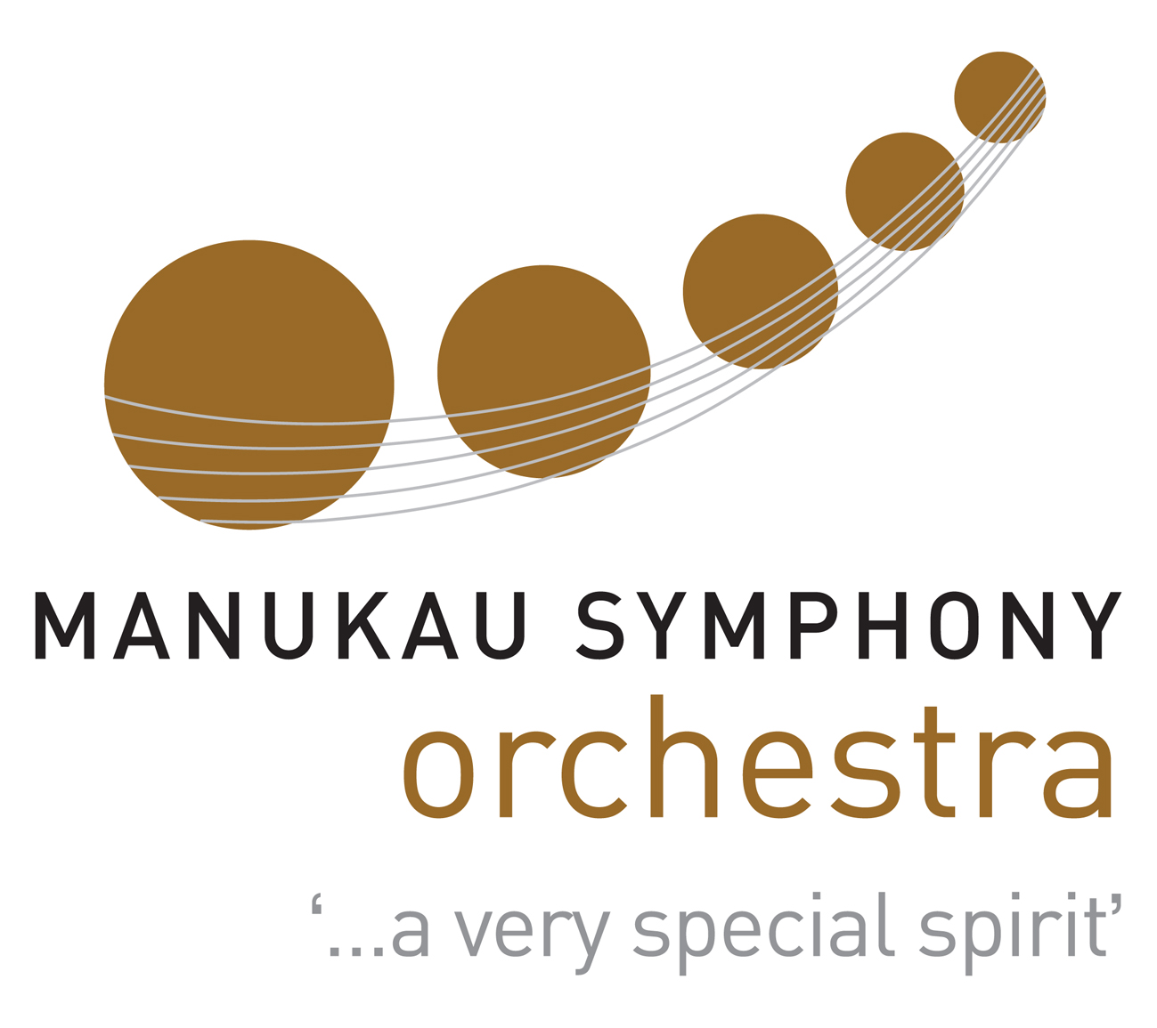
Manukau Symphony Orchestra Scholarships
APPLICATION FORM FOR 2025 SCHOLARSHIPS

The Manukau Symphony Orchestra is delighted to offer youth scholarships each year. Youth players are an important part of the Manukau Symphony’s ‘special spirit’ and this opportunity allows us to support our youth players to play alongside professional and community players of all ages and backgrounds.
Name ________________________________ Date of Birth _____________________
Residential Address ______________________________________________________
Phone __________________Email address ____________________________

Are you a Student? Yes / No
If so, tick one of these: At School _____ University _____ Other Tertiary _____
State name of School or University _________________________________________
Which Year are you in? ________________________________________
List the Exam subjects or course that you are doing ______________________________
________________________________________________________________________

Are you Working? Yes / No Part-time / Full time
Where? ________________________________________________________________________
What work do you do?

Musical Background (Add additional pages for the following questions if needed)
Instrument/Conductor Years played Grade reached Grade sitting this year
________________________________________________________________________
________________________________________________________________________
________________________________________________________________________

Your Music Teachers
Instrument Teacher’s name Contact Address Year you Year you
started lessons finished lessons
________________________________________________________________________________________________________________________________________________________________________________________________________________________________________________________________________________________________
List Orchestras & Groups in which you play or have played or conducted with the years played ________________________________________________________________________________________________________________________________________________________________________________________________________________________________________________________________________________________________
Why do you want to play or conduct in a Symphony Orchestra like MSO? ________________________________________________________________________
________________________________________________________________________
________________________________________________________________________

________________________________________________________________________

Check List. Do you meet ALL the following criteria?
Under 25 years of age at applying
Minimum playing / performing standard of Grade 6
Open to all NZ residents -Preference given to Manukau / South Auckland applicants
Prepared to play with the MSO Minimum of 2 out of 4 programmes in 2025
Enclosed a copy of your Birth Certificate (if not a NZ Citizen)

If there is not enough space in any of the sections above, or there is anything else you would like to tell us about your situation, musical studies, achievement and ambitions, please write more below and/or attach to your application and send to Shelley Robertson at admin@manukausymphony.org.nz

EMAIL YOUR APPLICATION TO: admin@manukausymphony.org.nz OR post to
MSO SCHOLARSHIPS,
P O BOX 38-233,
HOWICK,
AUCKLAND 2145

We must receive your Application Form by Sunday 20th October 2024

Signed: ____________________________

Date: ____________________________

